|  |  |
| --- | --- |
| **Team ID** | **PNT2022TMID15047** |
| **Project Name** | **Smart Waste Management for Metropolitan Cities** |

**NODE RED SERVICE**

Step 1: Connect the blocks.

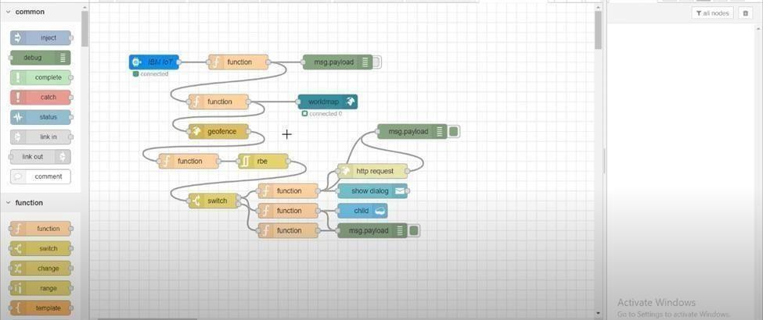

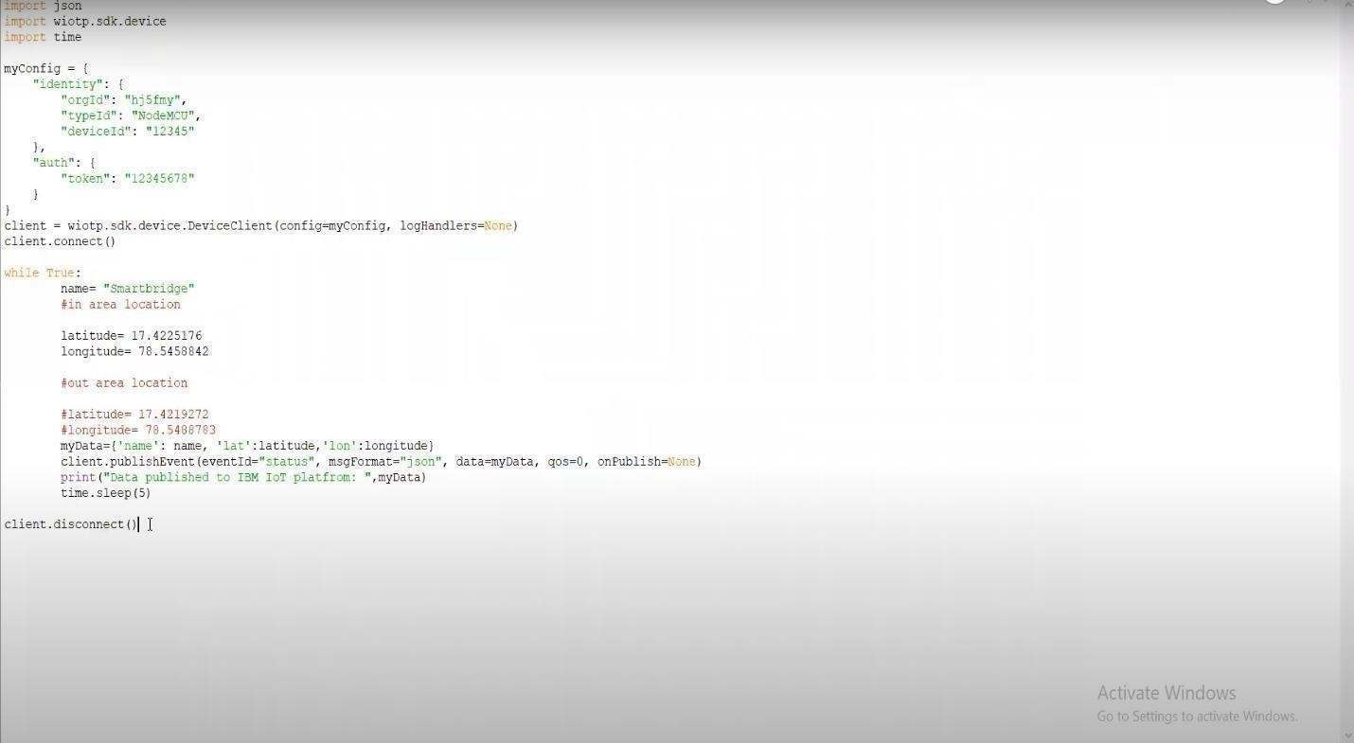

Step 3: Click the geo-fence node.

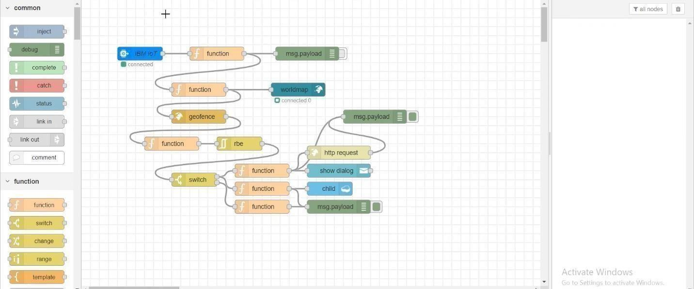

Step 4: Create the geo-fence area in the map.

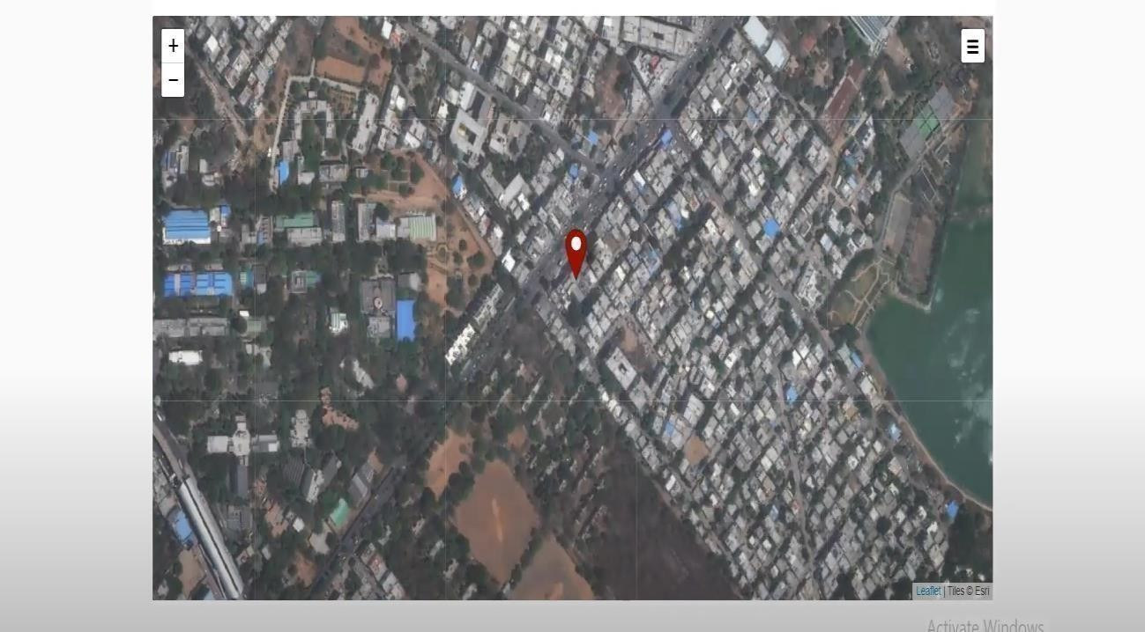

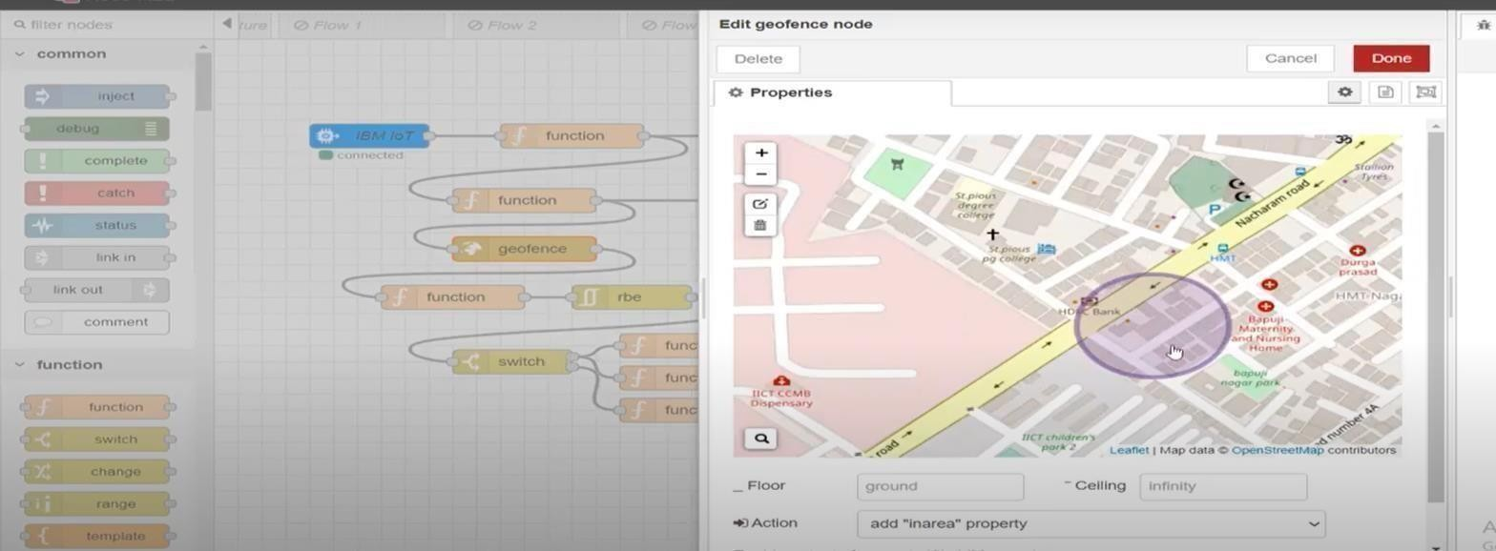5: Create geo-fence in a particular area.

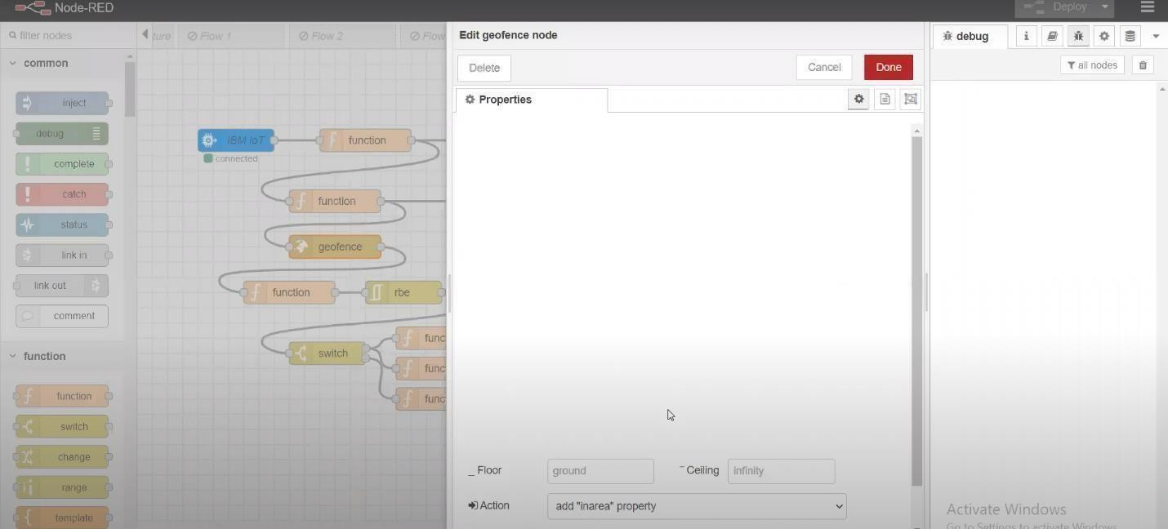

Step 7: Select the message payload.

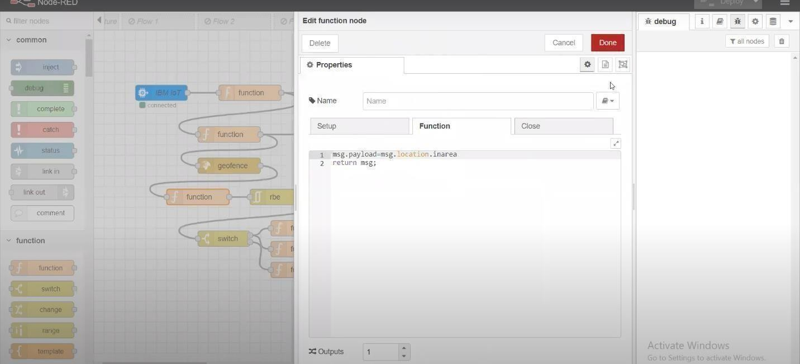

Step 8: To identify the person in area.

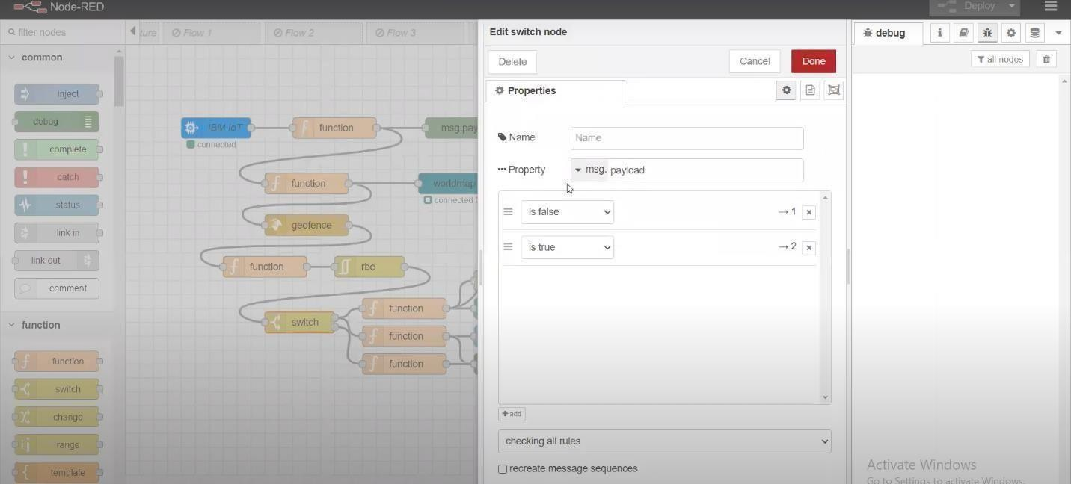

9: Select the http request to send message to parent or guardian.

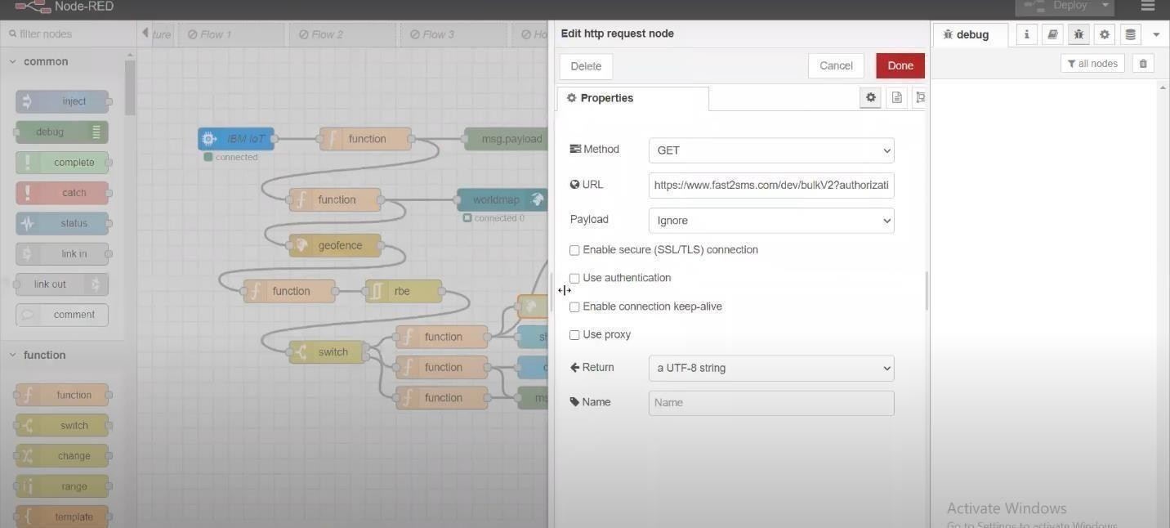

Step 10: For sending the message with time.

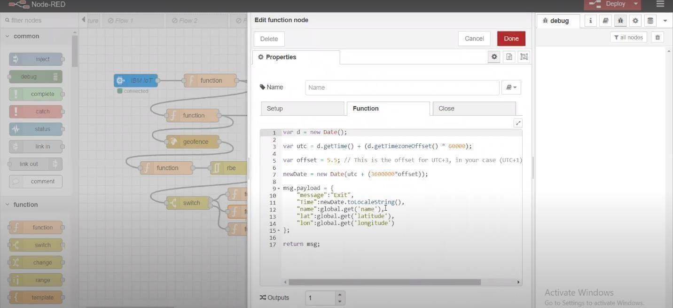

10: Click show dialog for notifying the popup alert.

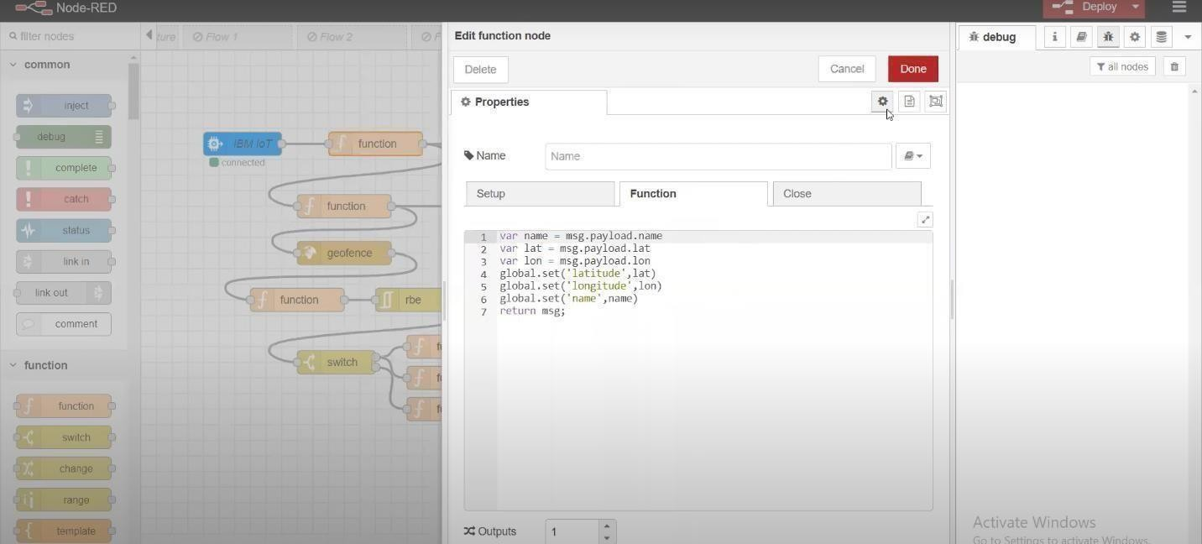

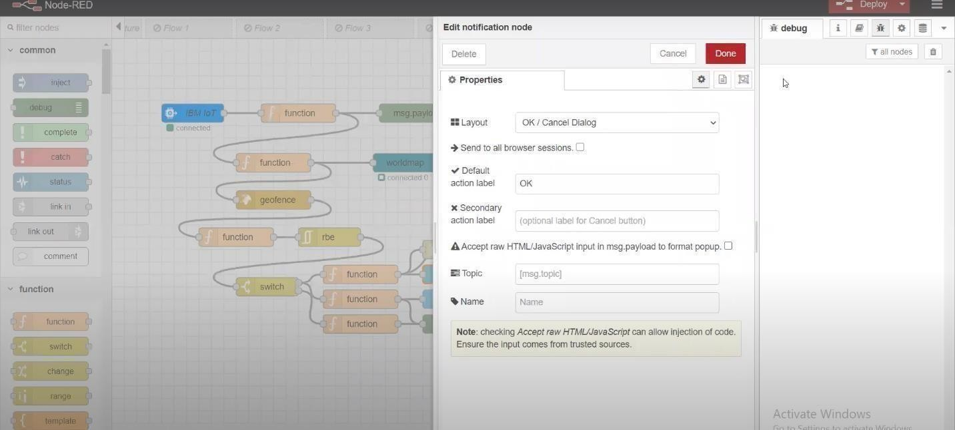

Step 11: Create another payload and to pass the data to geo-fence and world map.

12: Click the world map to see the location.

